Dear Parent / Guardian,

I am a children’s author and, on DATE, I will be spending the day at SCHOOL NAME Primary School. As well as working with the children, I will be selling signed copies of my books. If you think your child would like to buy a book and get it signed by me, it would be great if they could come with enough money (it doesn't have to be the exact amount – they can decide on the day which book they'd like). The books are aimed at Key Stage 2 children. Here are the prices:

**A Tiger Too Many: £6**

**Grown-ups Can't Be Friends With Dragons: £6.50**

**There Was An Old Fellow From Skye: £5**

**The Grubby Feather Gang: £6**

**Season of the Mammoth: £6**

You can find out about the books, and read the first chapters, here: [**www.antonywootten.co.uk**](http://www.antonywootten.co.uk)**.**

Yours sincerely,

**Antony Wootten.**

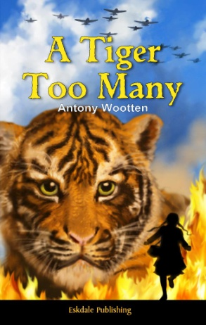 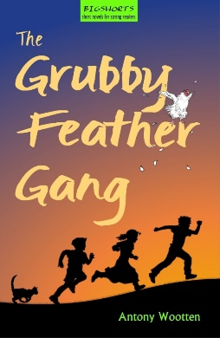 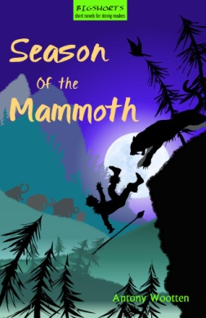 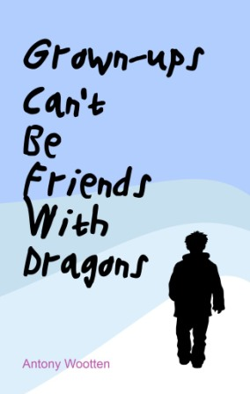 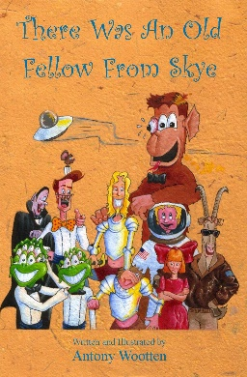

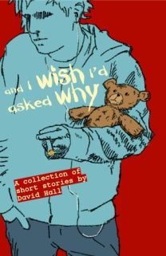PS: There's also something for the parents. When writing for adults, I use the pen name David Hall. I will bring copies of my short stories collection, called 'And I Wish I'd Asked Why' (£7), if you would like to buy a signed copy. You can find out more here: [www.antonywootten.co.uk/davidhall.html](http://www.antonywootten.co.uk/davidhall.html).

**Twitter: @antonywootten**

**Facebook: @awauthor**